Lucinda Keith, Bournedale Elementary, 2020
Welcome Scientists,
Bournedale Elementary School is interested in how quickly Spring is occurring in the year 2020. We need your help!!! They have asked that all second graders make observations and collect data to share at a later date.
Are YOU up for the challenge???????
We hope so!!!
Let’s get started on Your Mission!!!!!
- Read Your Mission with a parent/guardian. Both of you will then go outside to find a place to use for your observation.
HOW TO FIND YOUR OBSERVATION SQUARE:
- Go with your parent/guardian to locate your OBSERVATION SQUARE.
- This location should be easy to get to.
- Try to find a place that people won’t step on
- Try to find a sunny spot.
- Both of you will select your OBSERVATION SQUARE. (about 2 feet by 2 feet)
- You may want to mark it by outlining it with your finger or put a rock on each corner so you can find it easily next time.

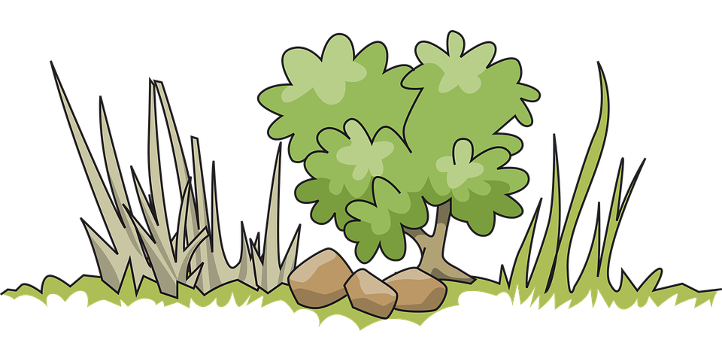
- Now that you have your OBSERVATION SQUARE……...bring along your supplies
*Blank Paper/Notebook (Field Journal)
*There is an attached Optional Data Sheet if you would like to print it to record/write your data
*Pencils
*Colored Pencils or Crayons (optional)
*Your Great Eye for Detail

- Draw a picture of your OBSERVATION SQUARE
  - Draw any rocks, dirt, grasses, leaves, plants, bugs, worms that you observe/see.
- If you have colored pencils or crayons, color the things you see with a matching color
- Record your data (you may use the Optional Data Sheet)
  - Date
  - Time of day
  - Temperature
  - Sunny, cloudy, partly cloudy
  - Any changes that you see

Thank you Scientists for your help!
HAVE FUN WATCHING SPRING IN BOURNE!!!!
Once a week you will go to the OBSERVATION SQUARE to sketch/draw what you see and record your data. Try to make your observations at the SAME time each day.
Date: Write the Month and day  Ex: 3/26/2020 | Circle cloudy or sunny | Outside temperature | Time of day | Write some changes that you see. If no changes write N/A
_____________ | Cloudy  Sunny | _________ | __________am  pm | _________________________  _________________________  _________________________
_____________ | Cloudy  Sunny | _________ | __________am  pm | _________________________  _________________________  _________________________
_____________ | Cloudy  Sunny | _________ | __________am  pm | _________________________  _________________________  _________________________
_____________ | Cloudy  Sunny | _________ | __________am  pm | _________________________  _________________________  _________________________

