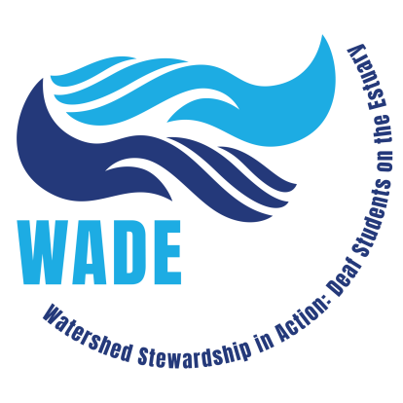
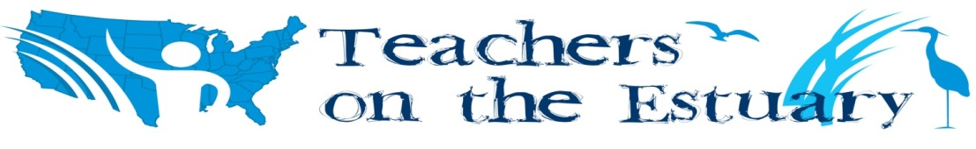

2021 Teachers on the Estuary (TOTE):
Watershed Stewardship in Action: Deaf Students on the Estuary (WADE)

Instructors
Barbara Spiecker, Postdoctoral scholar at University of California, Santa Barbara,
Mandy Houghton, Principal Investigator, Quantum Science in ASL Project at The Learning Center for the Deaf, Joan Muller, Education Coordinator, Waquoit Bay National Estuarine Research Reserve
And special guest presenters TBA

Who: Teachers, teacher aides, and ASL interpreters at schools for students who are deaf
Where: Waquoit Bay National Estuarine Research Reserve, 131 Waquoit Highway, Waquoit/East Falmouth, MA 02536 and three virtual sessions.
What: ASL vocabulary and conceptual STEM training- classroom, field, and on-line activities and resources plus discussions on culturally-responsive teaching.
Why: To give your students a leg up in the STEM fields and make learning more fun for you and your students in a culturally responsive way.
Agenda
When | Where | What
Due by Monday, August 2 | Virtual | asynchronous- watch 5 mini videos and videotape your own understanding of the content.
Monday, August 9  9:00AM - Noon | Virtual | Intro to NOAA on-line activities and ASL learning materials.
Monday, August 16  9:00AM – 4:00PM  (raindate: August 17) | In Person  Waquoit Bay Reserve | A Day at the Bay!
Monday, September 20  6:00PM – 8:00PM | Virtual | Develop implementation plans with colleagues
Monday, November 8  6:00PM – 8:00PM | Virtual | Sharing Session

Link to register: http://waquoitbayreserve.org/event-registration/?ee=1104

Additional Details:
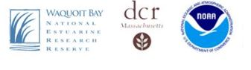
We will be in-person, outside all day on Monday, August 16 in Falmouth on Cape Cod, Massachusetts. Come get your feet wet learning about STEM topics including watersheds and coastal environments and creatures. Teachers will get hands-on experience using science and engineering practices from the Next Generation Science Standards. You will be introduced to educational activities from NOAA as well as ASL modules including instructional materials and ASL vocabulary related to estuaries and watersheds. The ASL modules are imbedded in ASL Clear, an on-line STEM educational resource made possible through funding from the Massachusetts Department of Elementary and Secondary Education and developed by researchers at the Boston University School of Education and The Center for Research and Training at The Learning Center for the Deaf. The instructors will guide your explorations and discussions on how to implement these instructional approaches and materials with your own students.

We will follow any Covid protocols in effect at the time, and our plan/hope is to be outside as much as possible. Lunch and snacks will be provided though participants may feel free to bring their own food.

What to bring for The Day at the Bay (August 16): We will be outside – on trails, the beach, marshes and getting our feet wet. Dress in layers (include long sleeve shirt and pants for sun and bugs as well as shorts and t-shirt). Bring a water bottle, travel mug, sunhat, sunglasses, sunscreen, insect repellent, extra water shoes or old sneakers that can get wet. You can leave your laptops/tablets at home- this is a day to be unplugged (though it might be handy to have your phone for photos or videos).

What’s in it for you?
- Improve your own understanding of coastal ecology and your ability to explain STEM concepts in ASL.
- Bring back engaging activities to use with your students (in both virtual and in-person classrooms).
- Earn a $100 presenter's honorarium for presenting on what you implemented with your students as a result of the workshop.
- Opportunity to set up a virtual classroom visit with a STEM professional who is deaf.
- Opportunity to bring one class for a real or virtual field trip to the Reserve (transportation for an in-person field trip would need to be provided by the school).
- Apply for PDPs from your school administration.
- Work towards a more culturally responsive classroom

What we expect of you:
- Attendance at all the sessions. In case of an unavoidable absence (stuff happens, we know that) we plan to record the virtual sessions so you can watch the one you missed and e-mail us your reflections.
- Do one asynchronous activity we provide and send it in a week before we begin the class as a diagnostic for Barbara and Mandy. Do the same activity after attending the learning sessions.
- Implement ASL and NOAA watershed/estuary education resources with your students and share with the other participants at the November 8, 2021 virtual session.

Questions? Contact: Joan Muller, joan.muller@mass.gov

Link to background about this project: http://graham.umich.edu/activity/40435
Link to ASL Clear videos for this project: http://www.nerrssciencecollaborative.org/resource/american-sign-language-video-lessons-estuaries

