Bringing Wetlands to Market Field Studies and Guidance for Adopting a Wetland

Basic Field Studies and Adopt-a-Wetland Projects

Introduction

These field studies bring together diverse concepts involved in the Bringing Wetlands to Market study and allow students to develop science process skills and practice solving technology and engineering problems. These activities present a variety of opportunities for students to become stewards of wetlands in their own community.

This document includes guidelines and procedures for basic field studies, more in-depth studies, and suggested stewardship projects.

Guiding questions for an initial site visit, including approaching the site as a system, relating the field study to carbon sequestration, and reviewing possibilities for stewardship, are included below. A student response page for first site visit based on the guiding questions is also included below.

The data recording sheet below includes a variety of parameters, but the field studies and research questions your class develops may only require a few of the parameters. Please modify and adapt the field study data sheets to use with your classes.

Please note: soil protocols are included in the section on soil studies below.

Studying and adopting a local wetland: Getting started

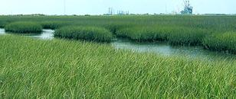
In the Bringing Wetlands to Market curriculum, students learn about wetlands and locate wetlands in their local area. By doing a field study they can learn more about their selected wetland areas and collect information and stories they can use to tell others about the wetlands and their importance. Students can initiate a stewardship project by identifying the ecosystem services provided by their chosen wetland and developing presentations and materials to communicate about this to the school or the broader community.
It is best if the students can visit their selected wetland site in person; however, if that’s not possible, you or a colleague can bring samples back to class for students to observe and process, and the wetland can be studied by the students virtually with many on-line tools that are described in the Bringing Wetlands to Market lessons.

The services that local wetlands and coastal ecosystems provide to wildlife and to the community are rarely recognized by residents. To educate peers or community members about these services, students can start by choosing a wetland to "adopt" as a focal area. Two useful first steps are developing a general description and examining soil samples.

Materials for a first site visit and soil study

Maps and information about local wetlands (guidance and resources for this are provided in BWTM Part 1, Exercise 3)

Trowel or soil coring tool for sampling

Camera for photographing study site

Clipboards and writing materials

Optional: field guide to plants, birds, or the region

Wetland soil color chart- available here

Basic wetland soil study procedures in “Our Wetlands, Our World” on pp. 47- 50 here

Procedure

1. In the Bringing Wetlands to Market curriculum Part 1 Exercise 3, students used maps to locate nearby wetlands; now ask them to choose one wetland to adopt and study. The most important consideration is to make sure the site does not pose significant safety risks and that it is publicly accessible, or that you can secure permission to visit the site and take soil samples.

A very important consideration is to plan activities in a way that does not harm or damage the site. When students are discussing which site to select, be sure they propose practices for low-impact sampling, to protect their study site from damage.

To find the area of their candidate wetland sites, students can locate each one using Google Earth and draw a polygon around it using the polygon function. They can copy the polygon and paste it into the free tool at Earth Point to find the area of the polygon.

If you have several candidate sites, some factors for deciding which site to choose for "adoption" are listed below. These are especially relevant if the students decide to make a public presentation about their adopted wetland as part of their stewardship project.

- Proximity to school and ease of access

- Whether it is typical of the area or unique

- Whether it is sizeable enough to be visited by many students without serious damage

- Whether it is protected by conservation restrictions or at risk for development or other impacts
- Whether it is likely to have a high rate of carbon sequestration; see Blue carbon fact sheet for guidance, and discuss with students some ways carbon might be taken up at the site

2. When a study site has been selected, it is important to go to the site yourself or have a colleague visit the site before bringing students there, to confirm that the site is safe and accessible, and that the students' visit will not cause damage.
In later sections of this activity, students will carry out sampling for several parameters, but if you have an opportunity to take them for an initial site visit to get a general overview of the site, it will be very helpful.
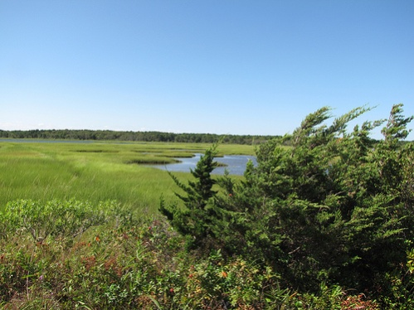
If you cannot bring your class to the site for an initial visit, on your own initial site visit you can take photos and collect soil samples to bring to class and introduce the site to students. Students can examine the photos and samples to answer most of the guiding questions provided below.
Before the students' site visit, have students use an existing map or aerial photo of the site to make a scaled outline map of the study area that they can use as a base for their added sketches and details.

3. Plan logistics, including obtaining permission to leave school grounds, transportation (it is ideal if students can walk to the site), assembling all safety and first aid equipment, and addressing practical considerations such as restrooms, snacks, and drinks for students.

If you can only visit the site once with your class, use the activities described here for the first site visit, and add the activities for observing and sampling parameters described in the section on "designing a student field study" below.

4. Review the observation and data collection protocols with students. The objectives for the first site visit should be

- Ensure that the site visit does not harm or damage the site

- Observe and make a general description of the site

- Take one or more soil samples from different locations

- Determine possible sampling locations which will not be significantly impacted by sampling activities

5. Before the site visit, prepare students by addressing these two aspects of the study:

a. Review the concept of a system. A system is defined as an organized group of related objects or components that form a whole (National Science Education Standards 1996). Systems have boundaries, components, resources flow (input and output), and feedback. The Next Generation Science Standards (NGSS) have designated systems as a cross-cutting concept that is important throughout the disciplines of science, technology, and engineering.

In the students' field study, they will consider their study site as a system. A short article introducing the concept of systems for students can be found at the Windows to the Universe web site (https://www.windows2universe.org/earth/ess1.html)

b. To relate the students' field study to the topic of carbon sequestration, discuss with students how their field study might compare to the research in the Bringing Wetlands to Market project. Ask them to suggest some similarities and differences.

Scientists in BWTM are working on the complex task of obtaining precise measurements to quantify greenhouse gas and nitrogen inputs and outputs, carbon in plants, and carbon in the soil. These measurements will help them calculate carbon storage in the salt marsh system.

Although your students will not have access to the sophisticated equipment, and cannot dedicate the time it would take to calculate those numbers for their own wetland, they will be able to take some of the same measurements as the professional scientists, and will solve similar problems and have some of the same discussions.

Guiding Questions

6. Below are suggested instructions to students for observations they could make in the field. These questions are included on the student data sheet below. Be sure to remind students to write down their own questions as they occur.

- When you first arrive at your site, stand back and view the wetland as a system. Look for inputs to the system, system outputs, and whether anything is being stored in the wetland. Where are the boundaries to the system? Take notes about this for a discussion later in class. Take notes to describe, and draw on your map, the main biotic (living) components and the abiotic (non-living) components of the site

- ‍Describe the different parts of the site; e.g., where it is wet, muddy, paved, overgrown. Consider: Are wetland plant roots visible? Are plants alive or dead? How might this affect the carbon uptake and storage capacity of the wetland?

- Make a few notes on how this site fits into the carbon cycle. Where is carbon being taken up? Where is it stored? Where is it being released?

- Is there evidence that the characteristics of the wetland change throughout the day or season? Are there tidal influences, for example, or higher water levels in winter/spring?

- ‍Is there anything unusual at the site that might influence the kinds of plants growing there - a wind-thrown tree, a large boulder, hummocky ground surface, etc.?

- ‍Describe any smells you notice. What might they signify?

- Can you observe any differences between the wetland plants and upland species? Can you identify any upland plants or trees?

- Is there any difference in the diversity of plants in the upland habitat compared to the wetland habitat?

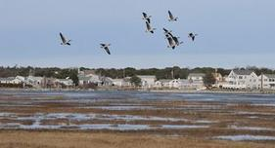
Look for signs of human impacts:
- Are there areas that have been dug out (dredged) or filled in?

- Has water been drained off the site?

- Is water coming on to the site through culverts or drainage ditches?

- How is the land used near the wetland? How might this affect the wetland?

- Are there old stone walls or other historical remnants?

- Have trees been removed?

Make notes and mark any of these findings on the base map.

If possible, document any evidence of harmful activity by photographing the portions of the wetland that show signs of filling, erosion, pollution, or improper development. These photos will be helpful as documentation to municipal officials, such as conservation commissions, who are interested in protecting community wetlands.

7. For soil characterization, have students use a trowel or soil coring device (described in more detail below). Have them take a sample of soil from the wetland and key out the color using the wetland soil color chart from Creek Connections available here.

Instructions for using soil color chart:

- Before or after the trip, have the students take a soil sample from the schoolyard or another area of interest to compare with the wetland soil.

- Use the color chart to help identify wetland soil. Wetland professionals use similar, but more complex, color charts to help them identify wetland soils. Hold the chart in one hand; in the other hand, hold a sample of soil behind the chart so that it is visible through one of the holes.

- Move the sample around until you find a color that nearly matches the color of the soil. Record this classification on the worksheet.

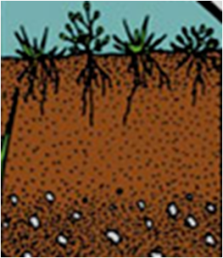
• Numbers 1, 5, 6, 9, 10, 13, 14, 15, 16, and sometimes 2 are probably wetland soils.

• Numbers 3, 4, 7, 8, 11, and 12 are probably not wetland soil.

• Numbers 14-16 are gleyed wetland soils and are most likely made of clay.

• Numbers 4, 8, and 12 can be used to match mottles (“rust spots”) that may be found in wetland soil.
As a rule of thumb, darker soil colors indicate higher levels of organic, or carbon-rich, soil.

Before or after the trip, have them take a soil sample from the schoolyard or another area of interest to compare with the wetland soil.

8. Optional activity: When students return to class, have them examine the soil samples by describing soil characteristics and relative organic and mineral content. This is a fun (though messy!) activity and provides good practice for students in comparing, and classifying their samples based on observed characteristics. Place an emphasis on comparing the amount of plant material above vs. below ground. Is your wetland storing carbon below the surface?

These initial studies can provide information and serve as a reference as students plan a sampling or stewardship project.

Stewardship component

A stewardship project is an important part of the students' wetland study. See the Bringing Wetlands to Market curriculum Part 4 Exercise 3 for ideas and guidance. It’s useful and informative to include input from local officials such as conservation agents when studying these fragile areas.
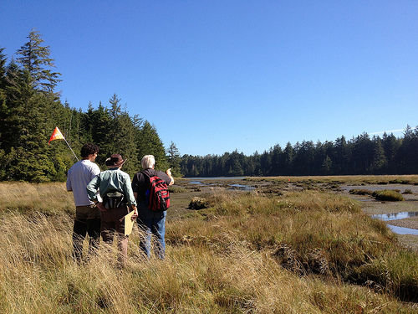
Students can make a commitment to monitor and/or clean up an area, as well as educate members of the community or other students about their wetland. Producing a Public Service Announcement for airing on local radio stations, or a student presentation at a community meeting is a great way to get the word out.

Teachers can encourage their students to create a 2-to5 minute video about their wetland and post it on a NERR or school web site as a way for students to compare their wetlands with others across the country. Videos could include information on the characteristics of the wetland, what services it provides for their community, and what environmental pressures exist for that wetland. Students may also use videos as a way to document their study.

Study Site Observations and Notes
Name: ___________________________ Date: _____________ Location: _____________________
- When you first arrive at your site, stand back and view the wetland as a system. Look for inputs to the system, system outputs, and whether anything is being stored in the wetland.

Inputs:

Outputs:

Storage:
- Where are the boundaries to the system? Take notes about this for a discussion later in class. Take notes to describe, and sketch a map with the main biotic (living) components and the abiotic (non-living) components of the site.

Boundaries:

Biotic components:

Abiotic components:
- ‍Mark on your map the different parts of the site; e.g., where it is wet, muddy, paved, overgrown. Make notes on these aspects:
  - Are wetland plant roots visible?
  - Are plants alive or dead?
  - How might this affect the carbon uptake and storage capacity of the wetland?

- Make a few notes on how this site fits into the carbon cycle.
  - Where is carbon being taken up?
  - Where is it stored?
  - Where is it being released?
- Is there evidence that the characteristics of the wetland change throughout the day or season? For example, are there tidal influences? Or higher water levels in winter/spring?

- ‍Is there anything unusual at the site that might influence the kinds of plants growing there, such as a windfall tree, a large boulder, hummocky ground surface, etc.?

- ‍Describe any smells you notice. What might they signify?

- Are there differences in the plant species found in the wetland and species in the upland areas?

- List the main species of wetland and upland grasses, shrubs, and trees

- Is there any difference in the diversity of plants in the upland habitat compared to the wetland habitat?

Look for signs of human impacts. Make notes and mark any of these findings on your base map.

 Are there areas that have been dredged (dug out) or filled in?

 Has water been drained off the site?

 Is water coming on to the site through culverts or drainage ditches?

 How is the land used near the wetland? How might this affect the wetland?

 Are there old stone walls or other historical remnants?

 Have trees been removed?

If possible, document your site, including any evidence of possible problems, by photographing the wetland and any parts that show signs of filling, erosion, pollution, or impacts of development. These photos will be helpful as documentation when you communicate about the site to others; as part of a stewardship project, you may wish to present your study results to municipal officials, such as conservation commissions, who are interested in protecting community wetlands.

Field Studies Environmental Data Form

Name: ______________________________ Date: ____________________

Location: _______________________________________________________

Time: ______________ Tide: low mid-tide high

Air temperature: _________ °C Water temperature: __________ °C

Cloud types: _____________________________ Cloud cover: ________________%

Wind speed: ____________________ Wind direction: _______________

Salinity: ___________ ppt pH: ________________

Dissolved oxygen: ______________ ppm % saturation: _______________%

Relative humidity: ___________% Barometric pressure: ______________mb

Clearness of water: _____JTU or circle one: clear slightly cloudy very cloudy

Light level or PAR: ______________________

Plants and algae observed:

Evidence of human activities:

Additional notes:

Sketch a map of the site on the back of this sheet:

